Vacuum Cleaner Problem

AIM:

To write a Python program to simulate a vacuum cleaner agent that cleans dirty rooms.

ALGORITHMS:
1. Start.
2.Initialize the room states as clean or dirty.
3. Place the vacuum cleaner in a room.
4.Check the room's condition.
5.If dirty, clean the room.
6. Move to the next room and repeat.
7.Display the final room states.
8.Stop.

CODE:
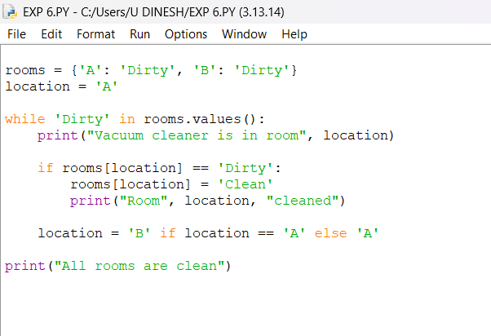
OUTPUT:
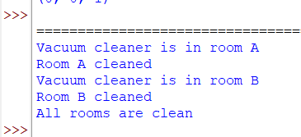
RESULT:
Vacuum Cleaner Problem: The vacuum cleaner visits the rooms and cleans all dirty locations.

